Java程序设计实验报告

学号： 120L022109
姓名： 李世轩
专业： 计算机与电子通信
班级： 120L0221

哈尔滨工业大学

实验报告五
- 实验内容
题目：基于类继承的思想，在编写一个媒体库管理程序，实现对CD、DVD、VideoGame、BoardGame四种媒体类型对象的进行统一管理，支持增、删、改、打印操作。
提示：请按照下图中类的继承关系编写程序。
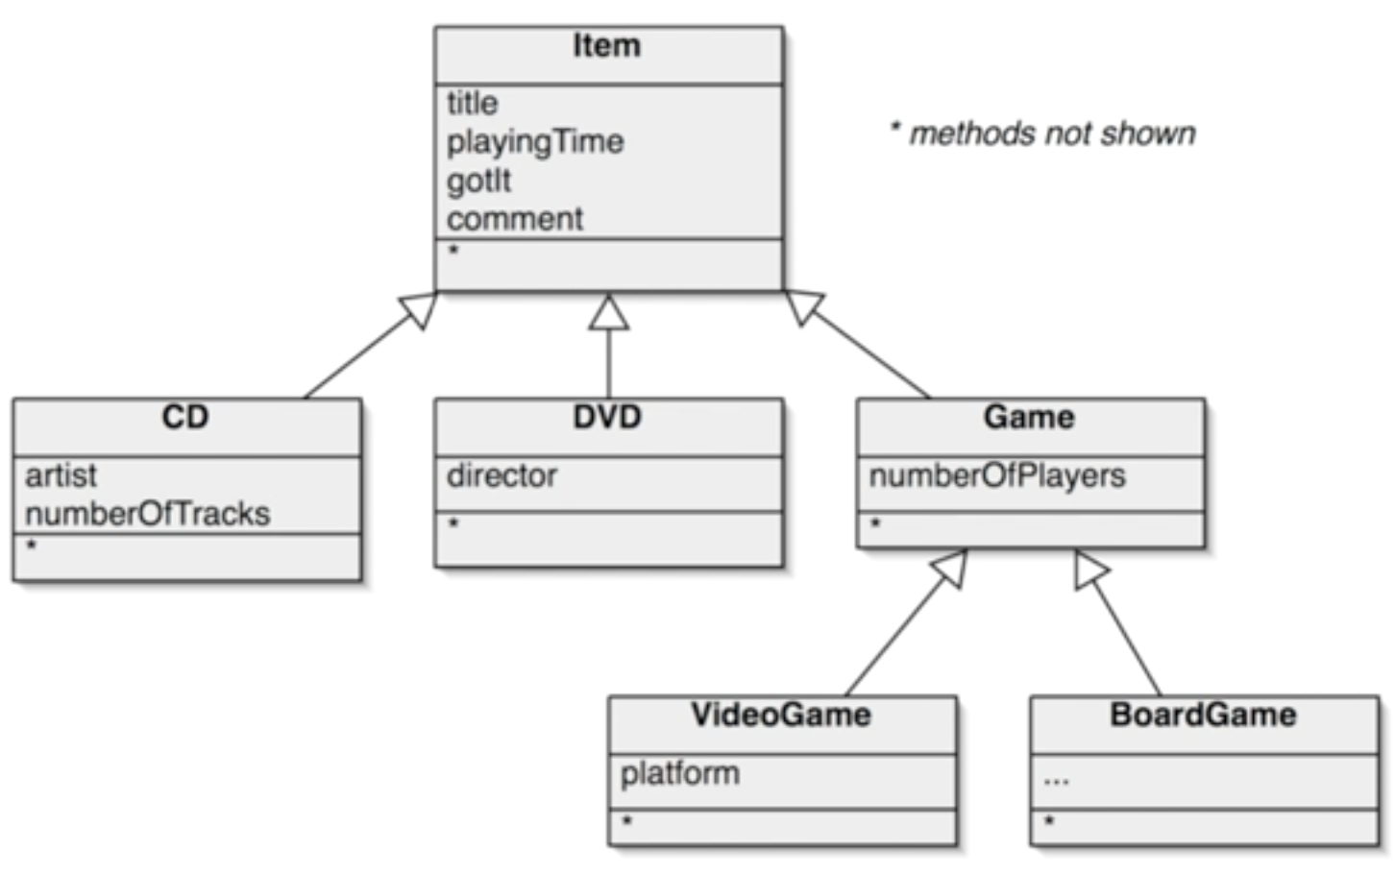

二、实验运行结果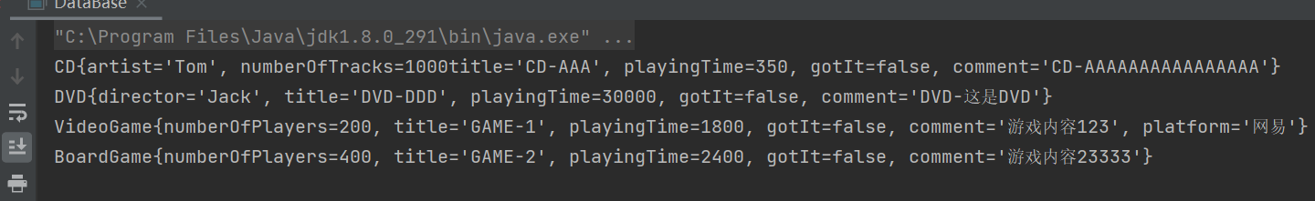

三、程序源代码

package fifth;

public class Item {
protected String title;
protected int playingTime;
protected boolean gotIt;
protected String comment;

public Item() {
}
public Item(String title, int playingTime, String comment) {
this.title = title;
this.playingTime = playingTime;
this.gotIt = false;
this.comment = comment;
}

public void print(){
System.out.printf("Item{" +
"title='" + title + '\'' +
", playingTime=" + playingTime +
", gotIt=" + gotIt +
", comment='" + comment + '\'' +
'}');
}
@Override
public String toString() {
return "Item{" +
"title='" + title + '\'' +
", playingTime=" + playingTime +
", gotIt=" + gotIt +
", comment='" + comment + '\'' +
'}';
}

public String getTitle() {
return title;
}

public void setTitle(String title) {
this.title = title;
}

public int getPlayingTime() {
return playingTime;
}

public void setPlayingTime(int playingTime) {
this.playingTime = playingTime;
}

public boolean isGotIt() {
return gotIt;
}

public void setGotIt(boolean gotIt) {
this.gotIt = gotIt;
}

public String getComment() {
return comment;
}

public void setComment(String comment) {
this.comment = comment;
}
}

package fifth;

public class CD extends Item{
private String artist;
private int numberOfTracks;

public CD(String artist, int numberOfTracks) {
this.artist = artist;
this.numberOfTracks = numberOfTracks;
}

public CD(String title, int playingTime, String comment, String artist, int numberOfTracks) {
super(title, playingTime, comment);
this.artist = artist;
this.numberOfTracks = numberOfTracks;
}

@Override
public void print() {
System.out.println("CD{" +
"artist='" + artist + '\'' +
", numberOfTracks=" + numberOfTracks +
"title='" + title + '\'' +
", playingTime=" + playingTime +
", gotIt=" + gotIt +
", comment='" + comment + '\'' +
'}');
}

@Override
public String toString() {
return "CD{" +
"artist='" + artist + '\'' +
", numberOfTracks=" + numberOfTracks +
"title='" + title + '\'' +
", playingTime=" + playingTime +
", gotIt=" + gotIt +
", comment='" + comment + '\'' +
'}';
}

public String getArtist() {
return artist;
}

public void setArtist(String artist) {
this.artist = artist;
}

public int getNumberOfTracks() {
return numberOfTracks;
}

public void setNumberOfTracks(int numberOfTracks) {
this.numberOfTracks = numberOfTracks;
}
}

package fifth;

public class DVD extends Item{
private String director;

public DVD(String director) {
this.director = director;
}

public DVD(String title, int playingTime, String comment, String director) {
super(title, playingTime, comment);
this.director = director;
}
@Override
public void print() {
System.out.println("DVD{" +
"director='" + director + '\'' +
", title='" + title + '\'' +
", playingTime=" + playingTime +
", gotIt=" + gotIt +
", comment='" + comment + '\'' +
'}');
}
@Override
public String toString() {
return "DVD{" +
"director='" + director + '\'' +
", title='" + title + '\'' +
", playingTime=" + playingTime +
", gotIt=" + gotIt +
", comment='" + comment + '\'' +
'}';
}

public String getDirector() {
return director;
}

public void setDirector(String director) {
this.director = director;
}
}

package fifth;

public class Game extends Item{
protected int numberOfPlayers;

public Game() {
}
public Game(int numberOfPlayers) {
this.numberOfPlayers = numberOfPlayers;
}

public Game(String title, int playingTime, String comment, int numberOfPlayers) {
super(title, playingTime, comment);
this.numberOfPlayers = numberOfPlayers;
}
@Override
public void print() {
System.out.println("Game{" +
"numberOfPlayers=" + numberOfPlayers +
", title='" + title + '\'' +
", playingTime=" + playingTime +
", gotIt=" + gotIt +
", comment='" + comment + '\'' +
'}');
}
@Override
public String toString() {
return "Game{" +
"numberOfPlayers=" + numberOfPlayers +
", title='" + title + '\'' +
", playingTime=" + playingTime +
", gotIt=" + gotIt +
", comment='" + comment + '\'' +
'}';
}

public int getNumberOfPlayers() {
return numberOfPlayers;
}

public void setNumberOfPlayers(int numberOfPlayers) {
this.numberOfPlayers = numberOfPlayers;
}
}

package fifth;

public class VideoGame extends Game{
private String platform;

public VideoGame(String platform) {
this.platform = platform;
}

public VideoGame(int numberOfPlayers, String platform) {
super(numberOfPlayers);
this.platform = platform;
}

public VideoGame(String title, int playingTime, String comment, int numberOfPlayers, String platform) {
super(title, playingTime, comment, numberOfPlayers);
this.platform = platform;
}
@Override
public void print() {
System.out.println("VideoGame{" +
"numberOfPlayers=" + numberOfPlayers +
", title='" + title + '\'' +
", playingTime=" + playingTime +
", gotIt=" + gotIt +
", comment='" + comment + '\'' +
", platform='" + platform + '\'' +
'}');
}
@Override
public String toString() {
return "VideoGame{" +
"numberOfPlayers=" + numberOfPlayers +
", title='" + title + '\'' +
", playingTime=" + playingTime +
", gotIt=" + gotIt +
", comment='" + comment + '\'' +
", platform='" + platform + '\'' +
'}';
}

public String getPlatform() {
return platform;
}

public void setPlatform(String platform) {
this.platform = platform;
}
}

package fifth;

public class BoardGame extends Game{
public BoardGame() {
}

public BoardGame(int numberOfPlayers) {
super(numberOfPlayers);
}

public BoardGame(String title, int playingTime, String comment, int numberOfPlayers) {
super(title, playingTime, comment, numberOfPlayers);
}
@Override
public void print() {
System.out.println("BoardGame{" +
"numberOfPlayers=" + numberOfPlayers +
", title='" + title + '\'' +
", playingTime=" + playingTime +
", gotIt=" + gotIt +
", comment='" + comment + '\'' +
'}');
}
@Override
public String toString() {
return "BoardGame{" +
"numberOfPlayers=" + numberOfPlayers +
", title='" + title + '\'' +
", playingTime=" + playingTime +
", gotIt=" + gotIt +
", comment='" + comment + '\'' +
'}';
}
}

package fifth;

import java.util.ArrayList;

public class DataBase {
private ArrayList<Item> listItem = new ArrayList<Item>();

public void add(Item item) {
listItem.add(item);
}

public void list() {
for( Item item : listItem) {
//System.out.println(item);
item.print();
}
}

public static void main(String[] args) {
DataBase db = new DataBase();
db.add(new CD("CD-AAA", 350, "CD-AAAAAAAAAAAAAAAA", "Tom", 1000));
db.add(new DVD("DVD-DDD",30000,"DVD-这是DVD","Jack"));
db.add(new VideoGame("GAME-1",30*60,"游戏内容123",200,"网易"));
db.add(new BoardGame("GAME-2",40*60,"游戏内容23333",400));

db.list();
}

}

